Wearable-Sensor Classification

of Daily and Sports Activities
  - Deep Learning Model Design, Training, and Evaluation with TensorFlow/Keras
Student Name | Duyaguit, Arnil Guron
Student Number | 152QCQTQ
Module | Applied Data Science 2
Dataset | UCI Daily and Sports Activities
Github Repository | https://github.com/agduyaguit/psba-asd2-assignment002

1. Problem Definition and Domain Understanding

1.1 Organizational Context and Prediction Problem
The assumed stakeholder of this assignment is a wearable-technology, sports-performance, or rehabilitation organization that needs automated recognition of physical activity from body-worn sensors. Accurate activity classification can support exercise monitoring, rehabilitation adherence, coaching feedback, and safety-related alerts.
The task was formulated as supervised multiclass classification. The input to each model was a five-second recording represented by 125 timesteps and 45 channels. The target was one of the 19 daily or sports activities. The main success criterion was strong performance on participants that is not present in the training data, because deployment users will generally have different movement amplitudes, rhythms, posture, and sensor-placement variations.
The raw input is sequential and multichannel. Movement information is expressed through local signal motifs, repeated cycles, timing relationships, and interactions among sensors placed on different body regions. A 1D CNN can learn local temporal filters directly from the raw sequences, while a BiLSTM can model longer relationship across the recording. Deep learning is therefore appropriate when predictive value depends on temporal structure that is lost when a sequence is reduced to summary statistics.
A simple tree-based model may remain preferable when the deployment environment has strict latency or memory limits, when labelled data are scarce, or when engineered statistics already separate the activities reliably. For this reason, XGBoost is retained as a mandatory baseline rather than assuming that deep learning must win.

1.2 Dataset Composition
The assignment verified, 9120 sensor files. Every file had the expected shape of 125 x 45, and no NaN or infinite values were detected. The 45 channels represented nine measurements at each of five body locations: three-axis acceleration, three-axis angular velocity, and three-axis magnetic-field measurements. The locations were the torso, right arm, left arm, right leg, and left leg.
Dataset | UCI Daily and Sports Activities
Task | 19-class time-series classification
Participants | 8
Activity Duration per Participant | 5 minutes per activity
Segments | 9, 120 five-second windows
Input per segments | 125 timestamps x 45 channels
Sensor Configuration | 5 body location x 9 axes
Sample per Activity | 480
Sample per Participant | 1140
Missing values | No non-finite expected; verified programmatically
Exact duplicate sequences | 0

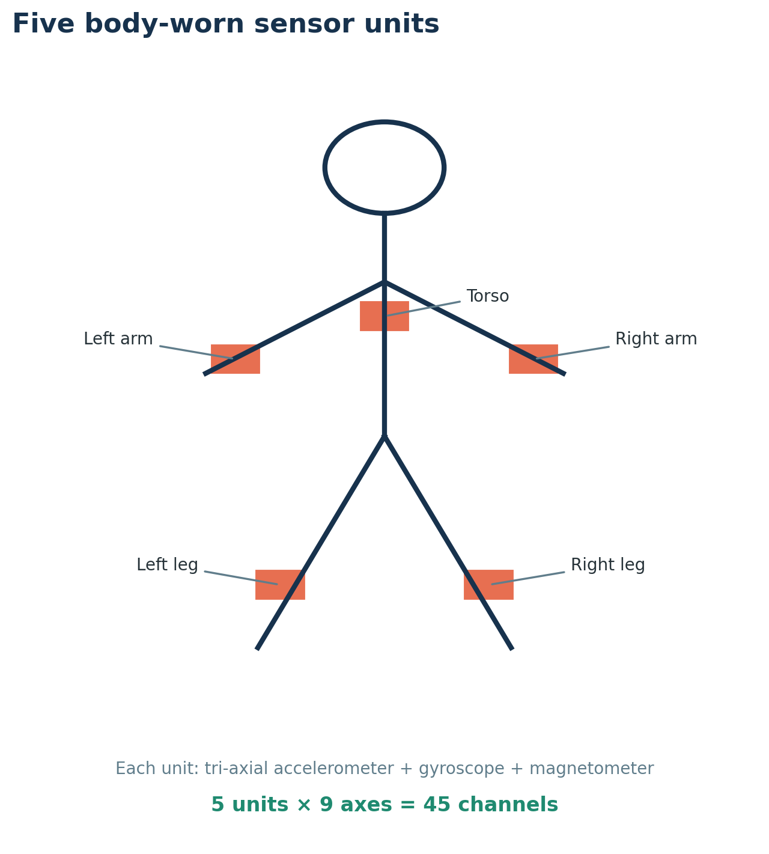
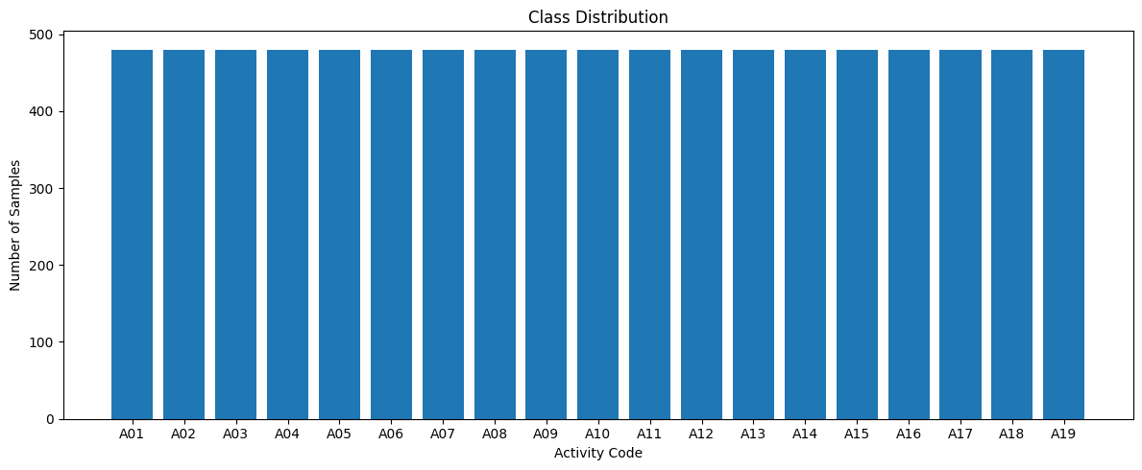
The dataset was perfectly balanced, with 480 recordings for each of the 19 activities.
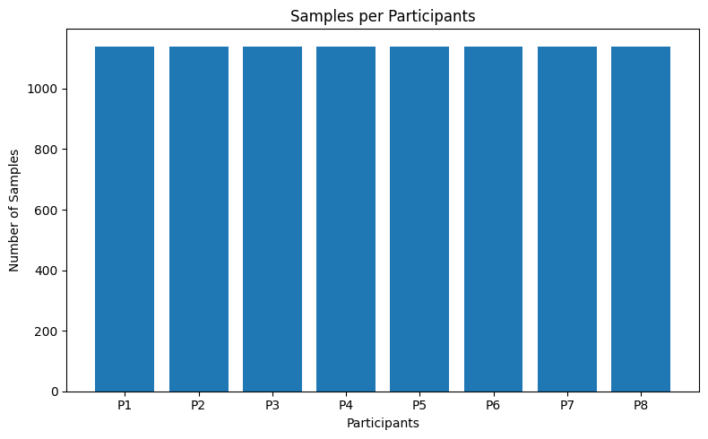
The dataset was perfectly balanced as well when it comes to Participant data, with 480 recordings for each of the 19 activities.

1.3 Exploratory Signal Analysis and Data Quality
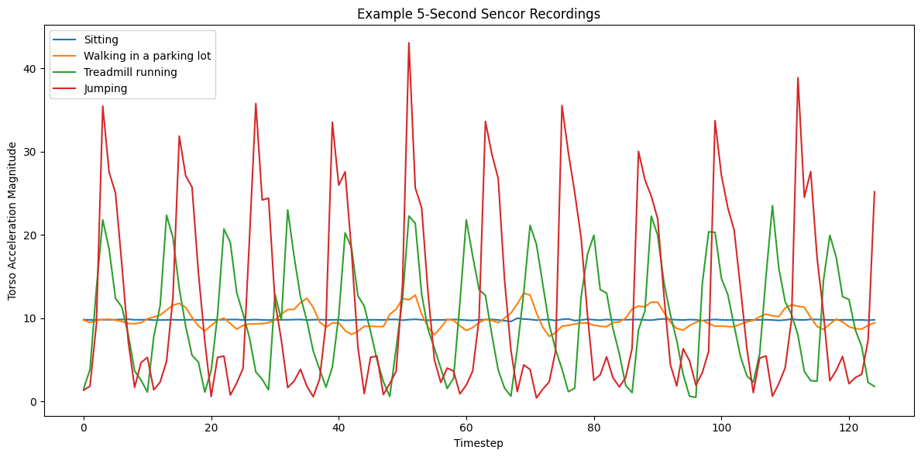
The example torso-acceleration plots showed clear differences in movement intensity. Sitting produced a relatively stable pattern, while walking, running, and jumping produced increasingly dynamic and periodic signals. These differences support the use of models that can capture both aggregate magnitude information and temporal structure.
 | channel | mean | standard_deviation | minimum | maximum
0 | Torso_acc_x | 7.765744 | 5.635097 | -99.714996 | 93.694000
1 | Torso_acc_y | -0.810956 | 2.621704 | -49.941002 | 41.013000
2 | Torso_acc_z | 2.768911 | 3.537025 | -62.664001 | 120.529999
3 | Torso_gyro_x | -0.002796 | 0.793810 | -27.851000 | 27.671000
4 | Torso_gyro_y | 0.013695 | 0.690814 | -23.598000 | 14.379000

Loaded arrays from cache: content/ADS2_A2_WearableHAR/data/processed/daily_sports_arrays.npz
Saved arrays to cache! content/ADS2_A2_WearableHAR/data/processed/daily_sports_arrays.npz
X shape: (9120, 125, 45)
y shape: (9120,)
Subjects shape: (9120,)
NaN count: 0
Infinite count: 0
Sequences involved in exact duplicate groups: 0

Channel distribution had different numerical ranges and variances. For example, the torso acceleration channels had substantially larger magnitudes than the gyroscope channels. This motivated channel-wise standardization before deep-learning training. No exact duplicate sequence where detected, reducing the risk of duplicated records crossing the data split.

2. Data Preprocessing and Input Pipeline

2.1 Participant-held-out Split
A random recording-level split would allow recordings from the same participants to appear in both training and testing that might create a risk that the model learns participant-specific movement patterns. Because of this, a group-wise split was used. P1-P5 were allocated for training. P6 for validation, and P7-P9 to testing. Because every participant contributed the same number of recordings for every class, the split remained perfectly class-balanced.

 | split | Test | train | validation
activity_code | activity_name
A01 | Sitting | 120 | 300 | 60
A02 | Standing | 120 | 300 | 60
A03 | Lying on back | 120 | 300 | 60
A04 | Lying on right side | 120 | 300 | 60
A05 | Ascending stairs | 120 | 300 | 60
A06 | Descending stairs | 120 | 300 | 60
A07 | Standing in a still elevator | 120 | 300 | 60
A08 | Moving around in an elevator | 120 | 300 | 60
A09 | Walking in a parking lot | 120 | 300 | 60
A10 | Treadmill walking, flat | 120 | 300 | 60
A11 | Treadmill walking, inclined | 120 | 300 | 60
A12 | Treadmill running | 120 | 300 | 60
A13 | Stepper exercise | 120 | 300 | 60
A14 | Cross-trainer exercise | 120 | 300 | 60
A15 | Exercise bike, horizontal | 120 | 300 | 60
A16 | Exercise bike, vertical | 120 | 300 | 60
A17 | Rowing | 120 | 300 | 60
A18 | Jumping | 120 | 300 | 60
A19 | Playing basketball | 120 | 300 | 60

Split | Participants | Samples | Sample per Class
Training | P1-P5 | 5700 | 300
Validation | P6 | 1140 | 60
Test | P7-P8 | 2280 | 120

2.2 Normalization
For the CNN and BiLSTM, a mean and standard deviation were calculated independently for each of 45 channels using only the training samples and timesteps. The same statistics were then applied to validation and test data. This prevented information leakage from held-out participants. After transformation, training-channel means were approximately zero and standard deviation were approximately one.

Train mean shape: (1, 1, 45)
Train std shape: (1, 1, 45)
First Five(5) scaled training means:
[-4.51507049e-06 -2.31406975e-05 3.40083716e-06 -1.01917985e-08
-8.10616498e-08 9.52909076e-08 6.41349616e-05 -5.79702885e-07
1.82271287e-05 -2.05749584e-05 -6.92367212e-06 8.39507084e-06
9.46183789e-08 1.05178898e-07 -9.45991374e-08 3.67813004e-06
-1.81672058e-05 1.12590669e-05 -3.45402853e-08 -9.25538734e-06
-1.63721415e-05 2.96086597e-07 -3.41286921e-07 -2.27415775e-08
-1.31458573e-05 9.58593864e-06 -1.57452869e-05 -2.58845944e-06
3.39913458e-05 3.69038571e-05 -2.93186257e-08 -6.17480055e-07
-3.84566654e-08 4.09983695e-05 -6.34755270e-06 9.94540187e-06
-3.81278478e-05 9.88322063e-06 1.37776874e-06 -2.50278021e-08
-8.41294650e-07 3.69158961e-08 3.35932818e-05 -4.83882286e-06
-7.21254082e-07]
First Five(5) scaled training standard deviations:
[0.9999456 1.0000505 1.0000151 1.0000364 0.99998605 1.0000217
0.9998422 0.99997693 1.000015 1.0000046 0.9999832 1.0000342
0.9999413 0.9999924 1.0000014 0.99998575 0.9999823 1.0000952
1.0000436 1.0000075 1.0000049 0.9999408 0.99998355 0.99999654
1.0000259 0.99996406 1.0000125 0.99999005 0.99999934 1.0000553
1.0000085 1.0000305 0.99997544 0.99997497 0.9999891 0.9999979
1.0000312 0.9999913 1.0000982 0.9999943 0.99994624 0.9999791
1.0000257 0.9999919 0.9999537 ]

2.2 Efficient TensorFlow Input Pipeline
The normalized arrays were converted to TensorFlow Dataset Objects. Caching, seeded shuffling, batches of 64, and automated prefetching were applied to the training pipeline to help with the performance of the training. Shuffling is important in training especially since the training is running in batches. Without shuffling, there is a tendency that it will only train single or repeated activity. The same techniques except for shuffling were applied to validation and test datasets to avoid and reduced repeated data loading overhead and most especially, these datasets are used for consistent evaluation.

2.3 Baseline Feature Engineering
The mandatory baseline transformed each 125 x 45 sequence into a fixed-length tabular vector. Eight statistics were computed independently for every channel: mean, standard deviation, minimum, maximum, median, range, root mean square, and mean energy. This produced 360 features per recording. The features retained overall magnitude, variability, extreme values, and signal energy while discarding exact temporal order.

Train feature shape: (5700, 360)
Val feature shape: (1140, 360)
Test feature shape: (2280, 360)
Number of feature names: 360

3. Architecture Design and Justification

3.1 XGBoost Baseline
XGBoost was selected as the baseline because boosted trees are strong learners for structured tabular data, can model nonlinear interactions among engineered features, and do not require feature standardization. The model used 350 estimators, a learning rate of 0.05, maximum depth of 6, 0.90 row subsampling, 0.90 column subsampling, and histogram-based tree construction. This baseline tested whether the activity classes could be separated using statistical summaries without learning the full sequence directly.

xgb_model = XGBClassifier(
objective="multi:softprob",
num_class=19,
n_estimators=350,
learning_rate=0.05,
max_depth=6,
min_child_weight=1,
subsample=0.90,
colsample_bytree=0.90,
reg_alpha=0.0,
reg_lambda=1.0,
tree_method="hist",
eval_metric="mlogloss",
random_state=SEED,
n_jobs=-1,
)

XGBoost validation accuracy: 0.8904
XGBoost validation macro F1 score: 0.8833
XGBoost training time: 74.18

3.2 One-Dimensional Convolutional Neural Network (1D CNN)
The CNN was designed to learn short and medium-range temporal patterns such as periodic steps, impacts, and changes in acceleration. It contained three Conv1D blocks with batch normalisation and ReLU activation to introduce non-linearity. The first two blocks used max pooling, while the final block was followed by global average pooling. A 64-unit dense layer and two dropout layers preceded the 19-class softmax output.

These layers were chosen to be applied for various reasons. L2 regularisation was applied to convolutional and dense kernels to reduce overfitting. It adds a penalty for large weight values to the training loss. This will encourage the model to use smaller, more distributed weights instead of relying heavily on a few features. Batch normalization was used to stabilize optimization while Max Pooling reduced temporal resolution and computation. Global Average Pooling reduces the parameter count compared with flattening, and Dropout was included to reduce co-adaption. The selected CNN used 32 initial filters, kernel size 5, dropout 0.30, and contained 173, 587 parameters.
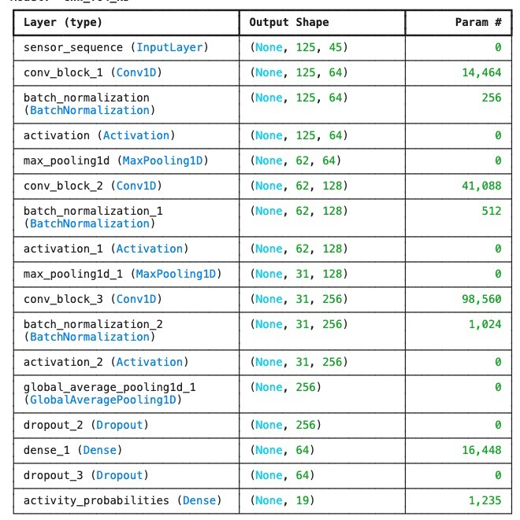
Total params: 173,587 (678.07 KB)
Trainable params: 172,691 (674.57 KB)
Non-trainable params: 896 (3.50 KB)

3.2 BiDirectional LSTM (BiLSTM)
The Bidirectional LSTM was selected as an alternative sequence model capable of representing dependencies across the complete five-second window. Bidirectionality was appropriate because the full recording was available before classification, allowing the representation at each timestep to use both earlier and later context.

The recurrent output retained the time dimension and was process by layer normalization, global average pooling, dropout, a 64-unit dense layer with L2 regularization, a second dropout layer, and a softmax classifier.

The selected BiLSTM used 64 units per direction, dropout 0.20, and contained 66, 067 parameters.
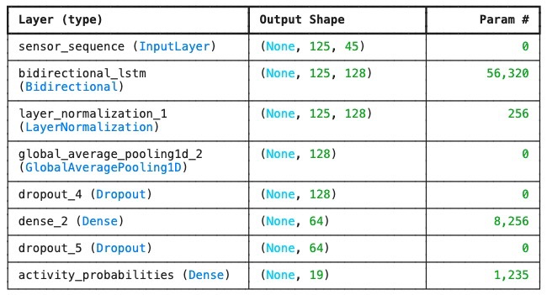
Total params: 66,067 (258.07 KB)
Trainable params: 66,067 (258.07 KB)
Non-trainable params: 0 (0.00 B)

3.2 Architectural Comparison
Approach | Information retained | Main Advantage | Main Risk
XGBoost | Channel-level statistical summaries | Robust on small, structured datasets; fast inference | Discard detailed temporal order
1D CNN | Local and hierarchical temporal patterns | Compact, parallelizable sequence processing | May learn individual movement styles instead of general activity patterns
BiLSTM | Longar-range bidirectional sequence context | Models temporal relationships across the window | Higher sequential cost and overfitting risk

4. Training, Optimization and Callbacks

4.1 Training Configuration
Both deep-learning models used the Adam optimizer with an initial learning rate of 0.001. Adam was selected because it adapts the learning rate for each parameter which is useful when training networks that contain different layer types and parameter scales. Sparse categorical cross-entropy was used because the task involved 19 mutually exclusive activity classes and the target labels were stored as integer values from 0 to 18. This approach will avoid converting the labels into one-hot vectors for classification problems. Training was limited to 10 epochs in the assignment for both deep learning models for comparability experiments. ModelCheckpoint saved the lowest-validation-loss model, ReduceLRonPlateau halved the learning rate after three stagnant epochs, and EarlyStopping used a patience of 6 and restored the best weights. The random seed was fixed at 42 for Python, NumPy, and TensorFlow.
Since the approach uses EarlyStopping patience of 6 and epochs is set to 10, a limitation was identified. The EarlyStopping configuration was relatively large compared with the 10-epoch training limit, meaning, the EarlyStopping had limited opportunity to terminate early. Still, this is chosen to strike a balance between overall training time and the opportunity to stop the training if the validation loss already plateaued.

================================================================================
Training: cnn_filters_32_kernel_3
================================================================================
Epoch 1/10
90/90 - 5s - 57ms/step - accuracy: 0.6267 - loss: 1.3889 - val_accuracy: 0.7246 - val_loss: 1.1381 - learning_rate: 0.0010
Epoch 2/10
90/90 - 1s - 16ms/step - accuracy: 0.9104 - loss: 0.3500 - val_accuracy: 0.8149 - val_loss: 0.6298 - learning_rate: 0.0010
Epoch 3/10
90/90 - 1s - 11ms/step - accuracy: 0.9577 - loss: 0.1815 - val_accuracy: 0.8211 - val_loss: 0.6684 - learning_rate: 0.0010
Epoch 4/10
90/90 - 1s - 11ms/step - accuracy: 0.9682 - loss: 0.1382 - val_accuracy: 0.8325 - val_loss: 0.6695 - learning_rate: 0.0010
Epoch 5/10
90/90 - 1s - 12ms/step - accuracy: 0.9765 - loss: 0.1124 - val_accuracy: 0.8588 - val_loss: 0.5421 - learning_rate: 0.0010
Epoch 6/10
90/90 - 1s - 11ms/step - accuracy: 0.9814 - loss: 0.0953 - val_accuracy: 0.8614 - val_loss: 0.4643 - learning_rate: 0.0010
Epoch 7/10
90/90 - 1s - 11ms/step - accuracy: 0.9816 - loss: 0.0962 - val_accuracy: 0.8553 - val_loss: 0.5593 - learning_rate: 0.0010
Epoch 8/10
90/90 - 1s - 11ms/step - accuracy: 0.9863 - loss: 0.0825 - val_accuracy: 0.8789 - val_loss: 0.5157 - learning_rate: 0.0010
Epoch 9/10

Epoch 9: ReduceLROnPlateau reducing learning rate to 0.0005000000237487257.
90/90 - 1s - 11ms/step - accuracy: 0.9819 - loss: 0.0996 - val_accuracy: 0.8728 - val_loss: 0.6105 - learning_rate: 0.0010
Epoch 10/10
90/90 - 1s - 12ms/step - accuracy: 0.9902 - loss: 0.0681 - val_accuracy: 0.8798 - val_loss: 0.5603 - learning_rate: 5.0000e-04
Restoring model weights from the end of the best epoch: 6.

================================================================================
Training: bilstm_units_32_dropout_0_2
================================================================================
Epoch 1/10
90/90 - 4s - 47ms/step - accuracy: 0.6030 - loss: 1.4751 - val_accuracy: 0.7447 - val_loss: 0.8831 - learning_rate: 0.0010
Epoch 2/10
90/90 - 1s - 17ms/step - accuracy: 0.9233 - loss: 0.3391 - val_accuracy: 0.8746 - val_loss: 0.5934 - learning_rate: 0.0010
Epoch 3/10
90/90 - 2s - 23ms/step - accuracy: 0.9728 - loss: 0.1383 - val_accuracy: 0.8807 - val_loss: 0.5390 - learning_rate: 0.0010
Epoch 4/10
90/90 - 2s - 23ms/step - accuracy: 0.9861 - loss: 0.0743 - val_accuracy: 0.8912 - val_loss: 0.5129 - learning_rate: 0.0010
Epoch 5/10
90/90 - 1s - 16ms/step - accuracy: 0.9916 - loss: 0.0549 - val_accuracy: 0.9061 - val_loss: 0.4874 - learning_rate: 0.0010
Epoch 6/10
90/90 - 1s - 15ms/step - accuracy: 0.9898 - loss: 0.0469 - val_accuracy: 0.8947 - val_loss: 0.5644 - learning_rate: 0.0010
Epoch 7/10
90/90 - 3s - 29ms/step - accuracy: 0.9947 - loss: 0.0361 - val_accuracy: 0.9211 - val_loss: 0.5114 - learning_rate: 0.0010
Epoch 8/10

Epoch 8: ReduceLROnPlateau reducing learning rate to 0.0005000000237487257.
90/90 - 3s - 28ms/step - accuracy: 0.9970 - loss: 0.0273 - val_accuracy: 0.9026 - val_loss: 0.5435 - learning_rate: 0.0010
Epoch 9/10
90/90 - 2s - 23ms/step - accuracy: 0.9958 - loss: 0.0294 - val_accuracy: 0.9132 - val_loss: 0.4820 - learning_rate: 5.0000e-04
Epoch 10/10
90/90 - 2s - 20ms/step - accuracy: 0.9975 - loss: 0.0230 - val_accuracy: 0.9123 - val_loss: 0.4547 - learning_rate: 5.0000e-04
Restoring model weights from the end of the best epoch: 10.

================================================================================

4.2 CNN Sensitivity Experiment
The CNN experiment varied the initial number of filters and kernel size. The 32-filter, kernel-size-5 configuration achieved the strongest validation Macro-F1 and was selected for final testing. Increasing the filters to 64 substantially increased the parameter count, and for kernel size 5, tripled the observed training time without improving the validation score.
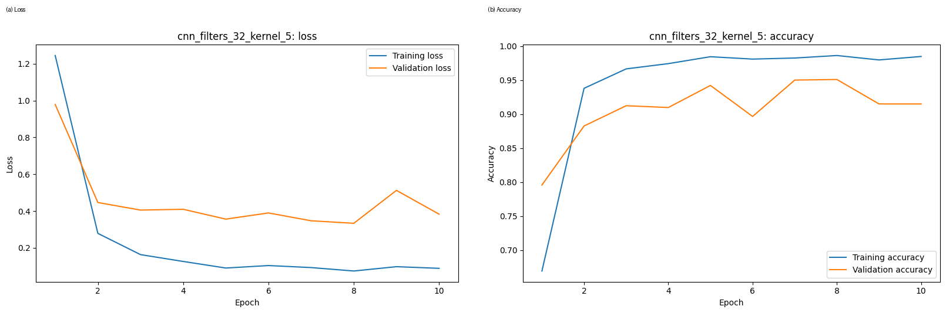

For the selected CNN, validation loss reached its lowest value at epoch 8. Training accuracy continued to remain very high, while validation accuracy fluctuated after its peak. The restored epoch-8 weights reduced the effect of the later deterioration, but the persistent training-validation gap indicates overfitting.

4.3 BiLSTM Sensitivity Experiment
The BiLSTM experiment varied the number of recurrent units and dropout rate. The 64-unit model with dropout 0.20 achieved the stronges validation Macro-F1. Increasing dropout to 0.40 did not improve generalization and produced the weakest result among the four BiLSTM configurations.

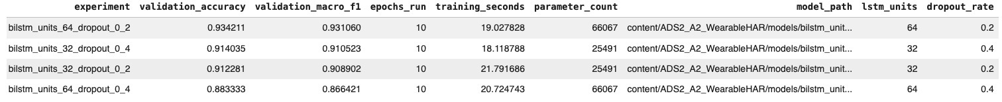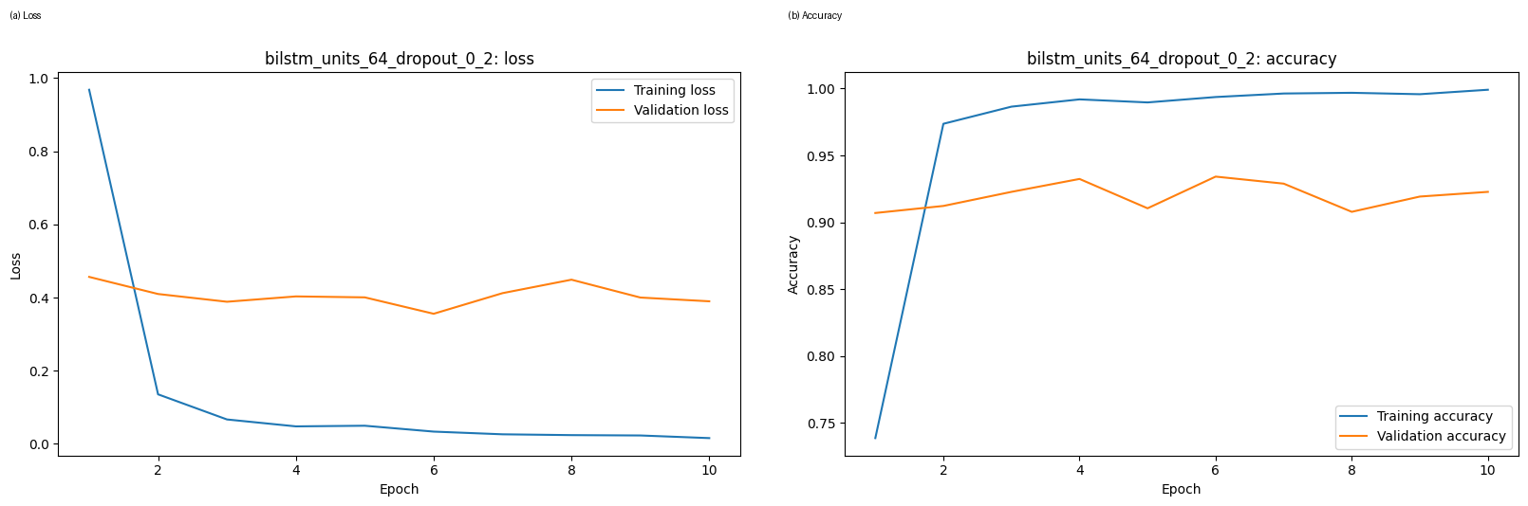The selected BiLSTM reached its lowest validation loss at epoch 6 and restored those weights. Training accuracy later approach 100%, while validation accuracy remained around the low of 90% range. The curve therefore showed clear memorization of the training participants without corresponding improvement on the validation participants.

5. Evaluation, Error Analysis and Baseline Comparison

5.1 Held-out Test Results
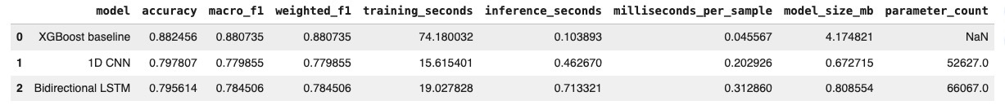

XGBoost was the stronges model, with 88.25% test accuracy and a Macro-F1 of 0.8807. It exceeded the CNN by 8.47 percentage points in accuracy and 0.1009 in Macro-F1. It exceeded the BiLSTM by 8.68 percentage points in accuracy and 0.0962 in Macro-F1. This is an important negative result: the deep-learning architectures were more complex but did not improve performance on unseen participants.

The baseline was also the fastest at inference, requiring approximately 0.0456 ms per sample in the recorded environment. The CNN had the smallest saved model at 0.673 MB, but its reduced sized did not compensate the accuracy loss. The latency values are environment-specific and should not be treated as comparative measurements rather than production benchmarks.

5.2 Validation-to-Test Generalization
XGBoost validation accuracy: 0.8904
XGBoost validation macro F1 score: 0.8833
XGBoost training time: 74.18

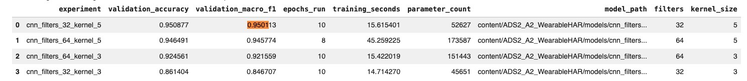

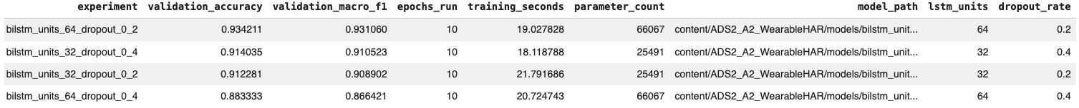

Based on these three results from the experiments, a validation-to-test generalization can be derived.

Model | Validation Macro-F1 | Test Macro-F1 | Gap
XGBoost | 0.8833 | 0.8807 | 0.0026
1D CNN | 0.9501 | 0.7799 | 0.1703
BiLSTM | 0.9311 | 0.7845 | 0.1466

The XGBoost validation Macro-F1 was 0.8833 and the test Macro-F1 was 0.8807, a difference of only 0.0026. In contrast, the CNN declined from 0.9501 to 0.7799, a gap of 0.1703, and the BiLSTM declined from 0.9311 to 0.7845, a gap of 0.1466. This pattern suggest that P6 was not an adequate single proxy for the movement distributions of P7 and P8. The deep-learning models were especially sensitive to participant-specific signal characteristics.

5.3 Confusion Matrix and Per-Class Analysis
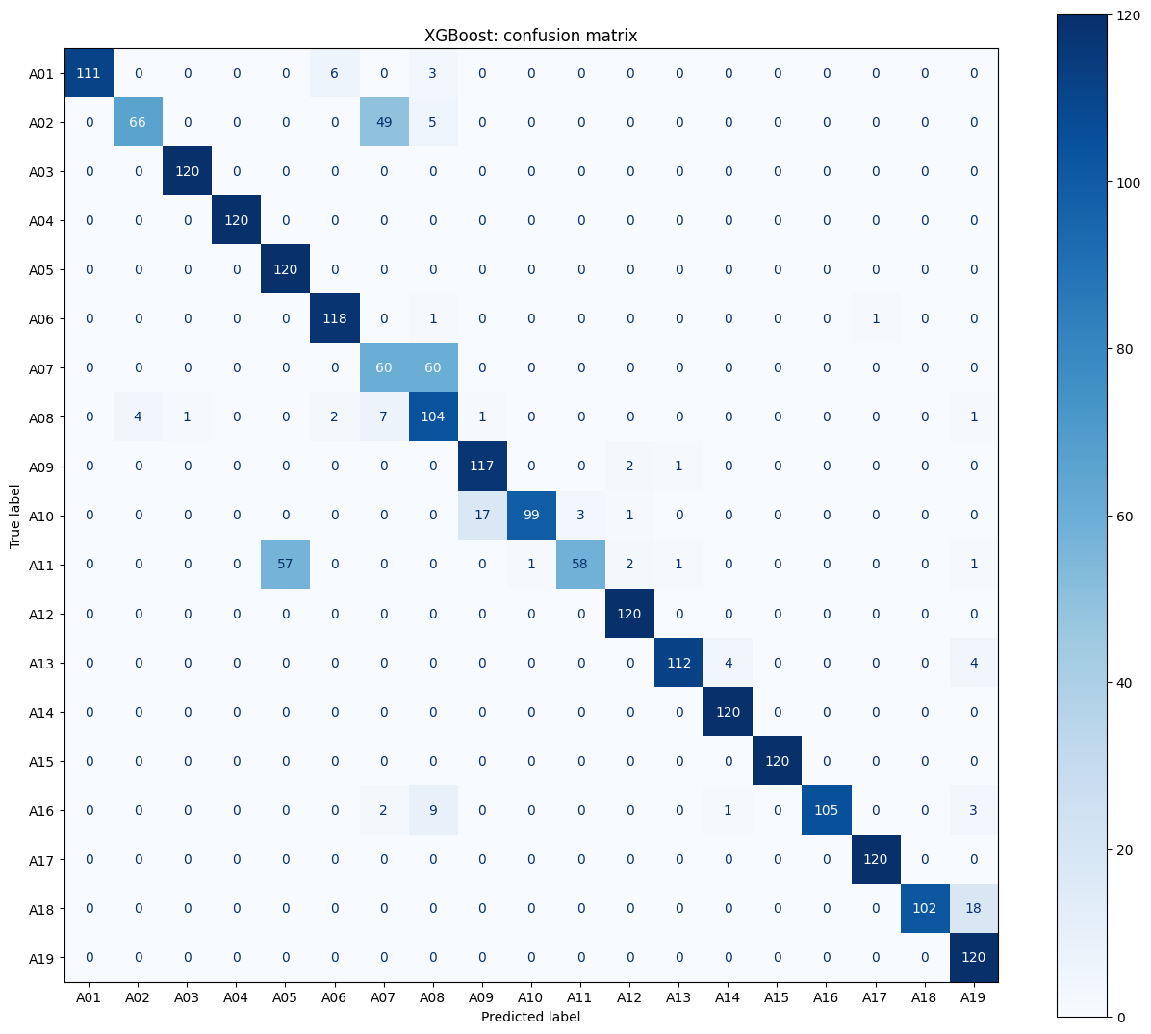

XGBoost classified many dynamic and posture-related activities very strongly. It obtained a perfect F1 scores for lying on the right side and horizontal exercise cycling, and near-perfect results for lying on the back, rowing, treadmill running, and cross-trainer exercise. Its main difficulties were the two elevator classes, Standing, and inclined treadmill walking.

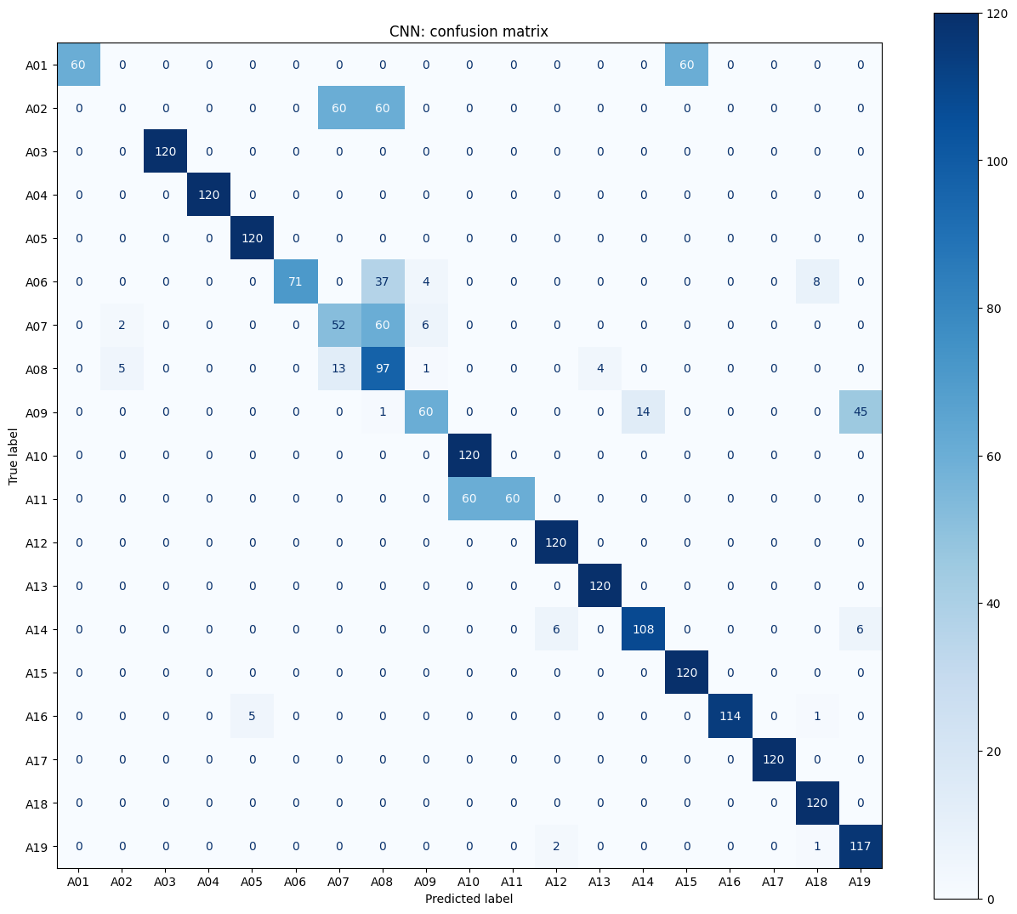
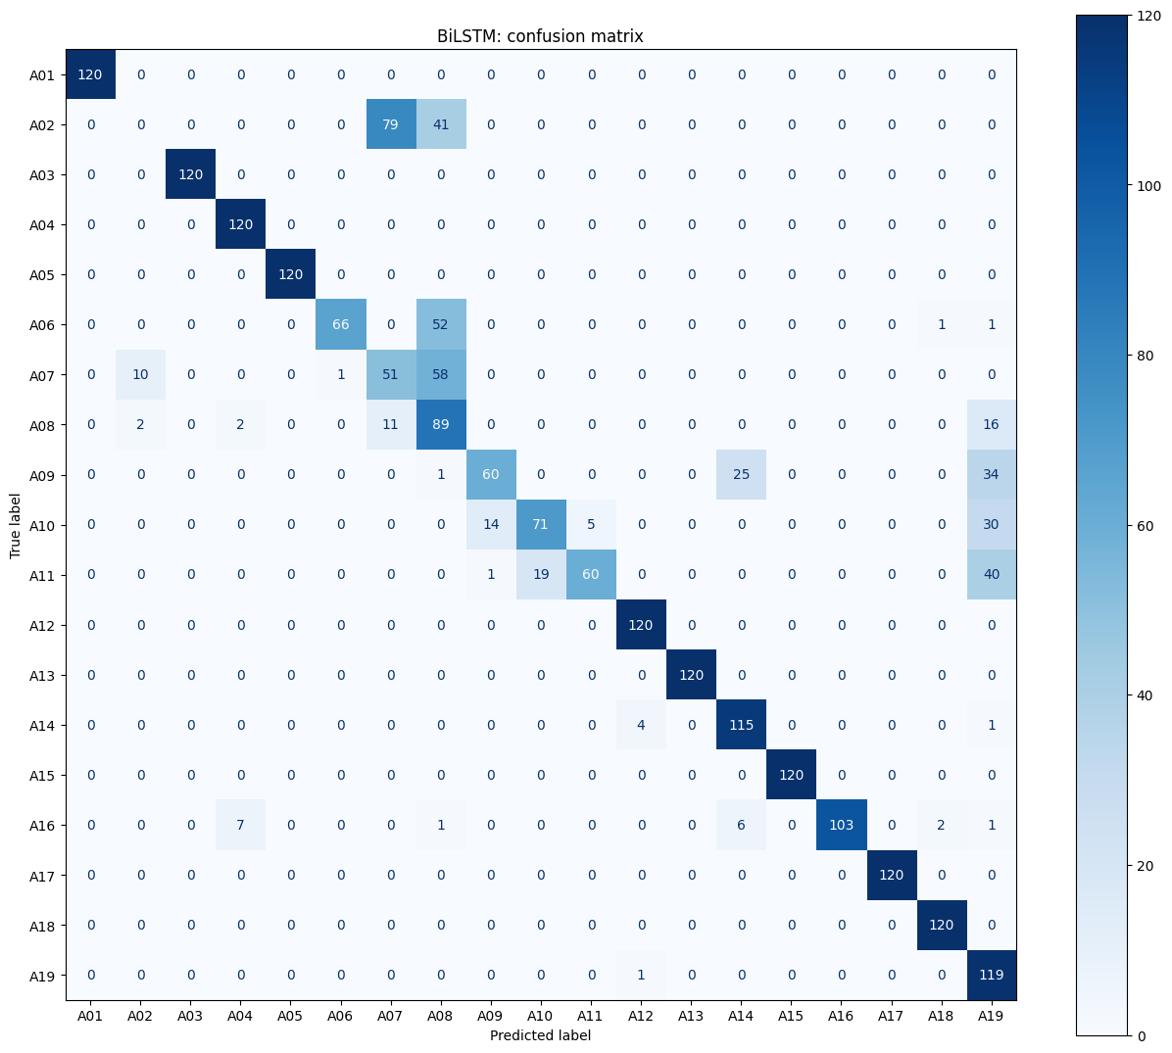

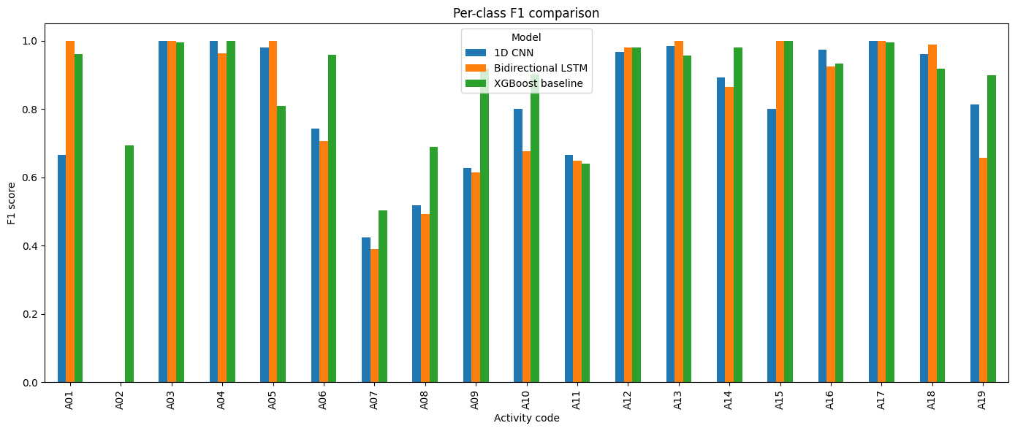
The deep-learning models had pronounced class-specific failures. Both produced zero precision, recall, and F1 for Standing. The CNN classified only half of the Sitting samples correctly and showed substantial confusion among standing, elevator, walking, and exercise classes. The BiLSTM recovered Sitting but still failed completely on Standing and had weak performance on elevator and walking-related classes.

5.4 Systematic Failure-Mode Investigation
The error analysis revealed that several failures occurred in blocks of 60 samples, which is the number of recordings contributed by one participant for one activity. Examples included all 60 Sitting recordings from one participant being predicted as horizontal exercise cycling, one participant’s Standing recordings being mapped to the still-elevator class and the other participant’s Standing recordings being mapped to the moving-elevator class, and all 60 inclined treadmill-walking recordings from one participant being classified as flat treadmill walking.

These block-level errors are more consistent with participant-dependent distribution shift than with random sample noise. The top high-confidence CNN errors included P8 still-elevator samples predicted as moving-elevator samples with confidence close to 1.0. This indicates that the model was not merely uncertain; it had learned a highly confident but non-generalizing decision boundary.

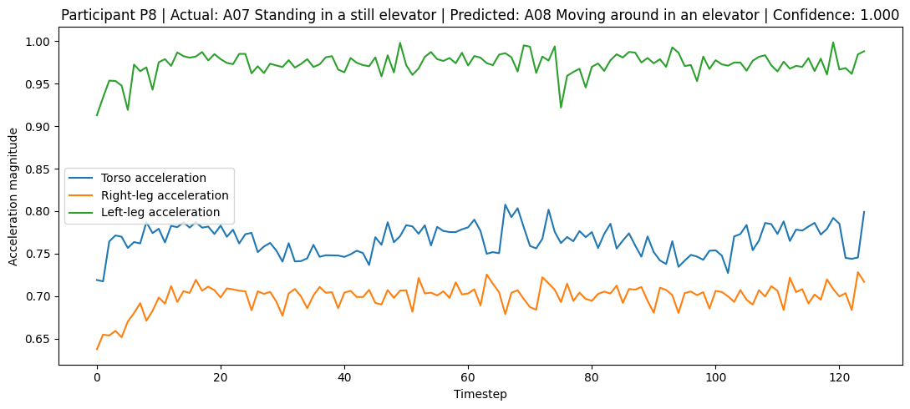5.5 Explainability
Input-gradient saliency was applied to a correctly classified P8 Sitting sequence. The predicted probability for the true class was 0.9236. When absolute gradients were aggregated by body location, the torso had the highest importance (0.002156), followed by the left leg (0.001929), right leg (0.001712), right arm (0.001547), and left arm (0.001271). The most influential individual channels included left-leg magnetic Y, torso acceleration Z, torso magnetic X/Y, and right-leg acceleration Y.

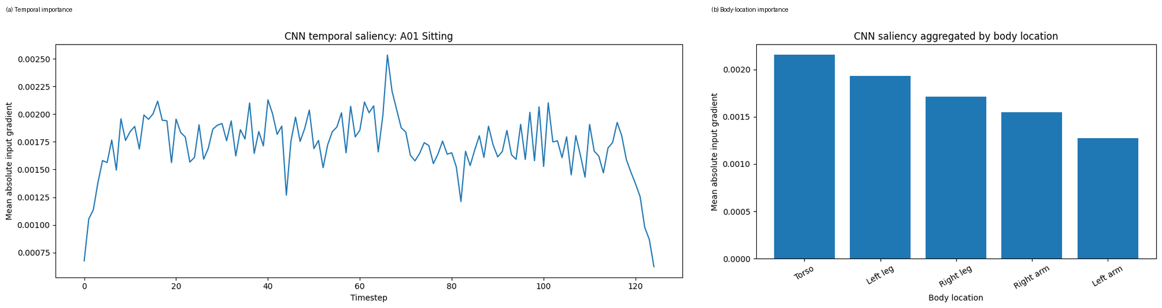The saliency output is consistent with Sitting being identified through torso orientation and lower-limb signals. However, input gradients are local sensitivity measures rather than casual explanations. Their magnitude can depend on input scaling and model saturation, so they should be interpreted together with error analysis and domain knowledge.

5.6 Deployment Considerations
Based on the experiments and results, considerations are the following:
- Model choice: XGBoost is the preferred candidate because it achieved the strongest held-out performance, the smallest generalisation gap, and the lowest inference latency.
- Edge versus server deployment: the CNN and BiLSTM files were smaller, but XGBoost remained only 4.17 MB and is still practical for many mobile or gateway environments.
- Sensor quality: deployment should detect missing channels, clipping, incorrect body placement, and calibration drift before classification.
- Monitoring: per-class confidence and distribution statistics should be monitored by device type and user. A sustained increase in uncertain or shifted predictions should trigger review or retraining.
- Privacy: raw wearable signals can reveal behavioural patterns. Data minimisation, encryption, retention controls, and informed consent are necessary.
- Human impact: activity predictions used in rehabilitation or safety settings should support rather than replace professional judgement.

6. Code Quality and Reproducibility
The notebook used modular functions for data loading, feature extraction, model construction, training, evaluation, confusion matrices, misclassification extraction, and saliency. Random seeds were fixed for Python, NumPy, and TensorFlow. Intermediate arrays, metadata, split manifests, normalisation statistics, model files, CSV results, figures, a requirements file, and environment settings were saved.

Component | Recorded value
Python | 3.12.13
TensorFlow | 2.20.0
NumPy | 2.0.2
Pandas | 2.2.2
Matplotlib | 3.10.0
Scikit-learn | 1.6.1
XGBoost | 3.3.0
Random seed | 42
Batch size | 64
Maximum deep-learning epochs | 10

